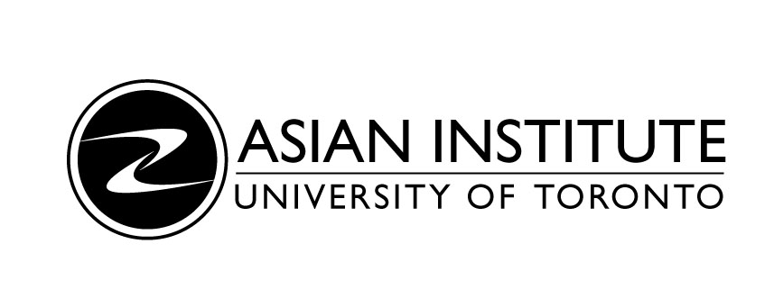

Dr. Onno Purbo

(Former International Development Research Centre Fellow)

Building the Internet from the Ground Up: The Indonesian Experience

Wednesday, June 1, 2005

12:00 – 2:00 p.m.

Munk Centre for International Studies
North House – Room 208N
1 Devonshire Place

Light Lunch Provided

Please register by e-mail to ai.events@utoronto.ca or call (416) 946-8996

“Dr. Onno Purbo is a self-confessed tech rebel. He was educated in Canada but returned to Jakarta to set up a technology movement whose innovative technologies prey on the margins of legality. His open-source philosophy is designed to equip Indonesian kids to participate in the knowledge economy.” –Ken Wiwa, Globe and Mail
Dr. Onno Purbo received his Master’s from McMaster University and his Ph.D in Electrical Engineering from the University of Waterloo. He is a former IDRC Fellow and the author of numerous articles and books about the Internet in Indonesia.

Co-Sponsored by the Indonesian Consulate

