TUGAS I

Tugas : contoh 2 divais & proses dari beberapa alternatif yang ada.
___________

Title SSUPREM 3 Example 1. NMOS Silicon Gate
Comment Gate Region
$ File s3ex1b

Comment Initialize silicon substrate
Initilaixe Structure=s3e1as

Comment Implant Arsenic for source/drain regions
Implant Arsenic Dose=5E15 Energy=150

Comment Drive-in Arsenic and re-oxidize source/drain regions
Diffusion Temperature=1000 Time=30 DryO2

Comment Deposit Phosphorus doped SiO2 using CVD
Deposit Oxide Thickness=.7500 Phosphorus Concentration=1.E21

Comment Increase the diffusivity of phosphorus in oxide by two order of magnitude
Phosphorus Oxide Dix.0=4.56E7

Comment Reflow glass to smooth surface and dops contact holes.
Diffusion Temperature=1000 Time=30

Comment Reopen contact holes.
Etch Oxide

Comment Deposit Aluminum
Deposit Aluminum Thickness=1.2 Spaces=10

Comment Plot the chemical impurity distributions at this point
Print Layer
Plot Chemical Boron Xmax=2.5 Clear Axis Linetype=2
+ title=Example-1b
Plot Chemical Arsenic Xmax=2.5 ^Clear ^Axis Linetype=3
Plot Chemical Phosphorus Xmax=2.5 ^Clear ^Axis Linetype=6
Plot Chemical Net Xmax=2.5 ^Clear ^Axis

Comment Save the structure.
Save Structure File=s3e1bs

Stop End of SSUPREM 3 Example 1.

Title SSUPREM 3 Example 2. Bipolar Ploy doped emitter.
$ Initial active region formation.
$ File s3ex2a

Comment Initialize silicon substrate
Initialize <100> Silicon, Boron Concentration=5e14
+ Thickness=5. dX=.01 XdX=.05 Spaces=100

Comment Grow masking oxide for non-active regions.
Diffusion Temperature=1150 Time=100 WetO2

Comment Etch the oxide over the buried layer regions.
Etch Oxide

Comment Implant and drive-in the antimony buried layer.
Implant Antimony Dose=5E14 Energy=120
Diffusion Temperature=1150 Time=15 DryO2
Diffusion Temperature=1150 Time=300
Print Layer
Plot Net Chemical Xmax=5
+ title=Example-2a1

Comment Etch off the oxide
Etch Oxide

Comment Grow 1.6 micron of arsenic doped epi.
Epitaxy Temperature=1050 Time=4 Growth.Rate=.4
+ Arsenic Gas.Conc=5E15

Comment Grow a 400A pad oxide.
Diffusion Temperature=1060 time=20 DryO2

Comment Deposit nitride to mask the field oxidation.
Deposit Nitride Thickness=.08

Comment Plot the chemical impurity distributions at this point
Print Layer
Plot Chemical Boron Xmax=5 Clear Axis Linetype=2
+ title=Example-2a2
Plot Chemical Arsenic Xmax=5 ^Clear ^Axis Linetype=4
Plot Chemical Antimony Xmax=5 ^Clear ^Axis Linetype=5
Plot Chemical Net Xmax=5 ^Clear ^Axis

Comment Save the simulation structure at this point for use in subsequent processing.
Savefile Structure File=s3e2as

Stop

Listing file untuk mencari DOPING PROFILE DIODA dengan PISCES2B
************************************************************

Date and time = 15-JAN-92 19:21:14

1... Title PN diode transient simulation
2... $ Grid of the structure and doping distribution
3... $ SILVACO International 1991

4... mesh rect nx=100 ny=10 smooth=1 diag.flip
5... x.m n=1 l=0.0 r=1.0
6... x.m n=100 l=10500.0 r=1.0
7... y.m n=1 l=0.0 r=1.0
8... y.m n=10 l=8.0 r=1.0
9... $ Regions and Electrodes
10... region num=1 silicon
11... elec num=1 x.min=0.0 length=999.0
12... elec num=2 bottom
13... $ Doping profile
14... doping uniform conc=1.2e15 n.type outf=dd1dio
15... doping gauss conc=1.2e17 p.type junc=0.922 x.r=10000.0 ratio=0.7
16... regrid doping ratio=4 log smooth.k=1 dopfile=dd1dio
17... regrid doping ratio=4 log smooth.k=1 outf=mesh.dd1 dopfile=dd1dio
18... $
19... plot.1d x.s=0.0 x.e=5.0 y.s=0.0 y.e=0.0 doping abs log pa
20... plot.1d x.s=1.0 x.e=1.0 y.s=0.0 y.e=5.0 doping abs log pa
21... plot.2d x.min=9950 x.max=10000 grid boundary no.top no.fill pa
22... plot.2d x/min=9950 x.max=10000 junction boundary l.elect=2 l.bound=3 l.junct=6 no.fill pa
23... end

*****************************
PN diode transient simulation
*****************************

Mesh statistics :
Total grid points = 1000
Total no. of triangles = 1782
Obtuse triangles = 0 ( 0.0%)

Mesh statistics :
Total grid points = 1385
Total no. of triangles = 2550
Obtuse triangles = 1332 ( 52.2%)

Mesh statistics :
Total grid points = 2430
Total no. of triangles = 4545
Obtuse triangles = 2182 ( 48.0%)

Grid written to mesh.dd1
Output :
1. Dioda
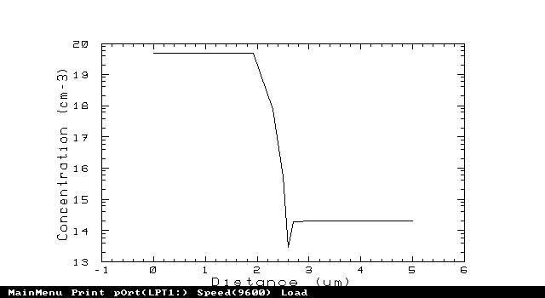
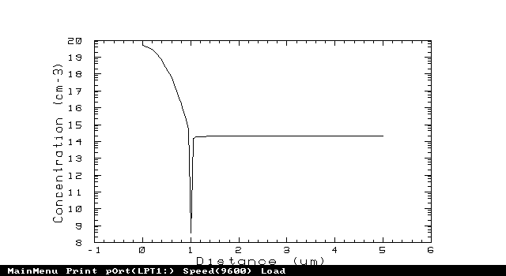
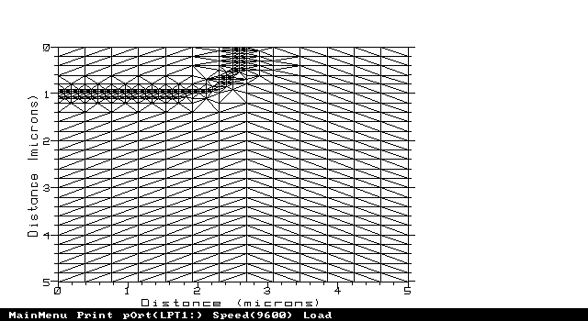
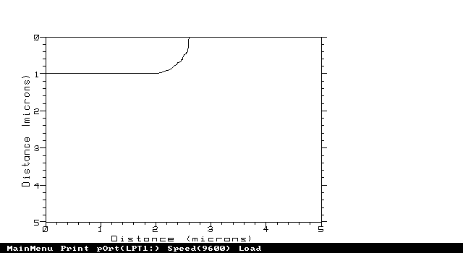
2. BJT transistor :
