TUGAS VIII

Tugas : mensimulasikan karakteristik I-V dan frekuensi tinggi transistor MOSFET.
_____________

Title N-channel MOSFET grid generation
$ Form grid of structure and give doping distribution
$ ****************** define rectangular grid **************
mesh rectangular nx=25 ny=25 diag.flip smooth=1
x.mesh n=1 l=1 r=1
x.mesh n=25 l=1 r=1
y.mesh n=1 l=-0.02 r=1
y.mesh n=3 l=0 r=1
y.mesh n=14 l=0.7 r=1.05
y.mesh n=25 l=2.5 r=1.2
$ ********** ******* regions ***************************
regions num=1 y.max=0 oxide
regioon num=2 y.min=0 silicon
$ ****************** electrodes ************************
$ #1-GATE #2-SUBSTRATE #3-SOURCE #4-DRAIN
electrode num=1 x.min=0.520 length=1.460
electrode num=2 substrate
electrode num=3 source length=0.417 y.min=0 y.max=0
electrode num=4 drain length=0.417 y.min=0 y.max=0
$ ****************** doping and fixed charge *************
doping reg=2 gaussian concentration=1.e16 characteristic=0.10
+ acceptor peak=0.0 outfile=dopingm
doping reg=2 gaussian concentration=1.e20 characteristic=0.10
+ donor peak=0.0 x.r=0.6 ratio=0.75
doping reg=2 gaussian concentration=1.e20 characteristic=0.10
+ donor peak=0.0 x.l=2.0 ratio=0.75
doping reg=2 uniform concentration=1.e16 acceptor
$ ****************** regrid on doping *******************
plot.2d grid no.top boundry no.fill pa
regrid doping log reg=2 ratio=4 smooth.k=1 outfile=gmesh1 dopfile=dopingm
regrid doping log reg=2 ratio=4 smooth.k=1 outfile=gmesh2 dopfile=dopingm
contact num=1 n.polysilicon
symbolic gummel carriers=0
solve initial
regrid potential ratio=0.2 region=2 smooth.k=1 outfile=gmesh3 dopfile=dopingm
plot.2d grid no.top boundry no.fill pa
plot.1d log abs doping x.s=0 y.s=0 x.e=0 y.e=1.5 points pa
plot.1d log abs doping x.s=0 y.s=0 x.e=2.5 y.e=0 line.type=2 pa
plot.1d log abs doping x.s=1.2 y.s=0 x.e=1.2 y.e=1.5 line.type=2 pa
end

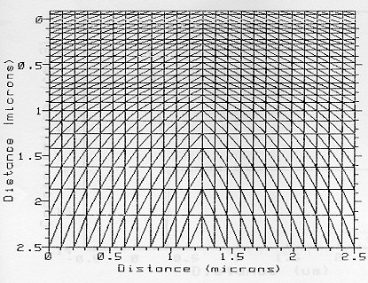
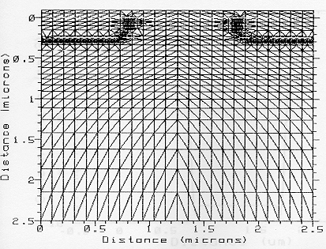

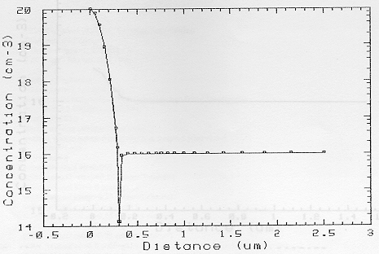
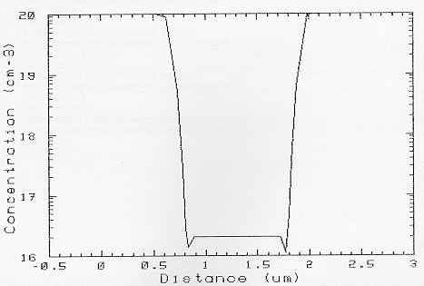
Title N-channel MOSFET Id/Vd characteristic
Mesh inf=gmesh3
Contact num=1 n.polysilicon
Models print temp=300 conmob fldmob bgn fermi incomplete
+ tfldmb2 OX.L=0.6 OX.R=2
interf qf=3E10
symb newton carrier=1 selectrons
method xnorm autonr itlimit=30 trap=.5 p.tol=1.e-4
+ c.tol=1.e-4
solve initial
solve previous v4=0.005
solve project vstep=0.25 nstep=3 elect=1
solve project v1=1.0 outf=g111
solve project vstep=0.25 nstep=3 elect=1
solve project v1=2.0 outf=g211
solve project vstep=0.25 nstep=3 elect=1
solve project v1=3.0 outf=g311
solve project vstep=0.25 nstep=3 elect=1
solve project v1=4.0 outf=g411
load inf=g111
log outf=d111
solve vstep=0.1 nstep=9 elect=4 previous
solve previous v4=1.0 vstep=0.1 nstep=40 elect=4
load inf=g211
log outf=d211
solve vstep=0.1 nstep=9 elect=4 previous
solve previous v4=1.0 vstep=0.1 nstep=40 elect=4
load inf=g311
log outf=d311
solve vstep=0.1 nstep=9 elect=4 previous
solve previous v4=1.0 vstep=0.1 nstep=40 elect=4
load inf=g411
log outf=d411
solve vstep=0.1 nstep=9 elect=4 previous
solve previous v4=1.0 vstep=0.1 nstep=40 elect=4
end

Title N-channel MOSFET I/d/Vd characterisation
Mesh inf=gmesh3
Plot.1d inf=d411 x.ax=v4 y.ax=i4 abs x.label=VDS y.label=IDS pa
+ title=”Fitting of NMOSFET” max=3.9e-4
+ subtitle=”output characteristic”
plot.1d inf=d311 x.ax=v4 y.ax=i4 abs unch pa
plot.1d inf=d211 x.ax=v4 y.ax=i4 abs unch pa
plot.1d inf=d111 x.ax=v4 y.ax=i4 abs unch pa
fit mos fit.type=2 bulk=2 drain=4 gate=1
+ line1.type=4 line2.type=5

Titile N-channel MOSFET substrate Current
Mesh inf=gmesh3
Plot.1d inf=substr5 x.ax=v1 y.ax=i2 abs x.label=VGS y.label=Isub log points pa
+ title=”Substrate current” subtitle=”versus gate bias NMOSFET”
plot.1d inf=substr4 x.ax=v1 y.ax=i2 abs log points unch pa
end
Title N.channel MOSFET substrate Current extraction
Mesh inf=gmesh3
Contact num=1 n.polysilicon
Models print temp=300 conmob fldmob bgn fermi incomplete
+ tfldmb2 OX.L=0.6 OX.R=2
impact
interf qf=3E10
symb carrires=0
method iccg damped itlimit=30
solve init
solve v1=0.3 v4=4.0 local outf=sb4
solve v1=0.3 v4=5.0 local outf=sb5
symb newton carriers=2
load inf=sb4
solve prev v1=0.4 vstep=0.1 nstep=6 elect=1
solve prev vstep=0.25 nstep=8 elect=1
solve prev vstep=0.50 nstep=8 elect=1
load inf=sb5
solve prev v1=0.4 vstep=0.1 nstep=6 elect=1
solve prev vstep=0.25 nstep=8 elect=1
solve prev vstep=0.50 nstep=8 elect=1
end

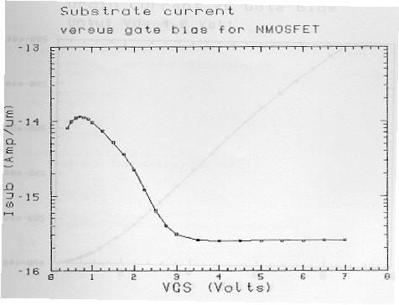

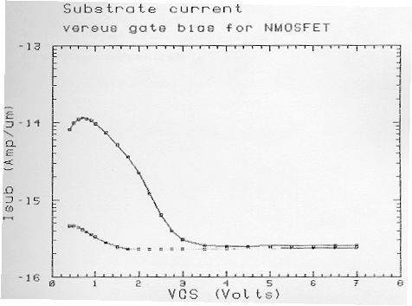
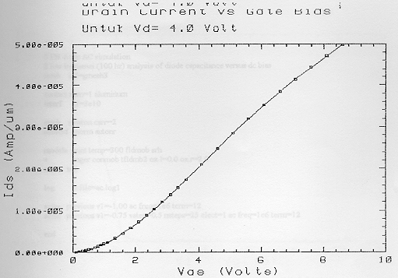

$ PN dioda AC simulation
mesh inf=gmesh3
contact num=1 aluminum
interf qf=3e10
symb newton carr=2
method xnorm autonr
models print temp=300 fldmob srh
+ auger conmob fldmob tfldmb2 ox.l=0.0 ox.r=2.0
solve init
log acfile=ac.log1
solve previous v1=1.00 ac freq=1e6 term=12
solve previous v1=-0.75 vstep=0.5 nstep=25 elect=1 ac freq=1e6
+ term=12
end

$ PN dioda AC simulation
mesh inf=gmesh3
plot.1d inf=ac.log1 x.ax=v1 y.ax=e12 points pa
end

